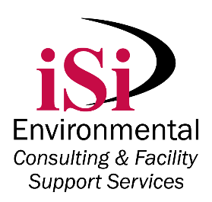A long-time Kansas Chamber member, iSi helps companies manage their environmental and safety risks. iSi has two brands, iSi Environmental, a consulting and facility support services company and iSi Industrial Services, an asbestos and lead abatement firm. iSi Environmental helps companies comply with EPA and OSHA regulations with reports, permits, and sampling, while providing hands-on support through activities such as hazardous waste management, industrial cleaning, and wastewater treatment plant management.



Karma and Gary Mason founded iSi from the dining room table of their home. They started with a computer, a phone, a fax machine, and a checking account containing $700. Gary was a chemical engineer; Karma was a geologist. Many of their friends and colleagues told them they were stupid to leave their steady jobs to set out on their own, but they had a desire for challenging themselves and both had an entrepreneurial spirit that is still strong today.

Today, iSi has over 160 employees and is a regional leader in its fields, working with companies from all across the U.S. iSi has satellite offices in Atlanta, Georgia and Tulsa, Oklahoma.

In 2015, Gary moved on to become Deputy Secretary of the Kansas Department of Health and Environment. Karma remains at iSi as President and CEO and their children are also involved in the business, making it a truly family-owned business.

Karma Mason said, “I’ve had the privilege of working with some truly outstanding employees, clients and people…I am truly blessed.”

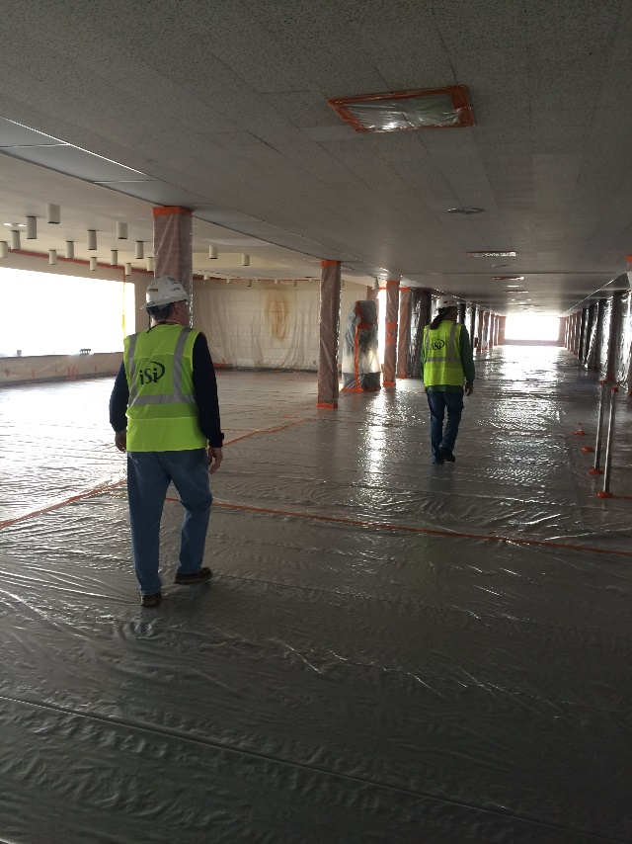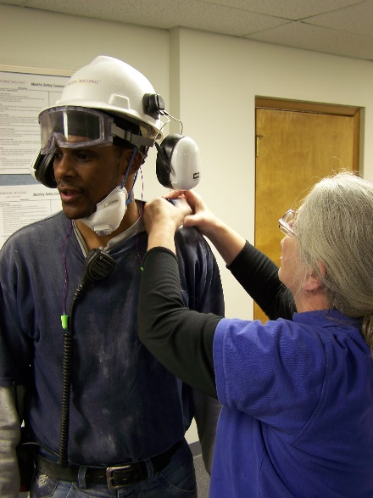

Left: An iSi Environmental industrial hygienist prepares a worker for occupational noise testing

.

Above: iSi Industrial Services project managers survey the preparations for asbestos abatement of a former Wichita Mid-Continent Airport terminal prior to its demolition.

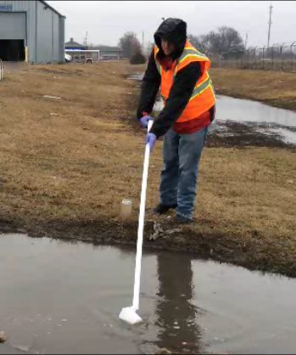

Left: An iSi Environmental environmental scientist conducts stormwater sampling.